Phase 4 -

# Step 1: Create Validation Rules

Validation Rules help ensure that data entered into Salesforce is correct and consistent. You will create different rules for Fees, Attendance, and Admission Date.

1. Navigate to: Setup → Object Manager → Student__c → Validation Rules → New.

2. Enter Rule Name and Formula.

3. Add Error Message and choose Error Location (Field or Top of Page).

4. Save and Activate the rule.

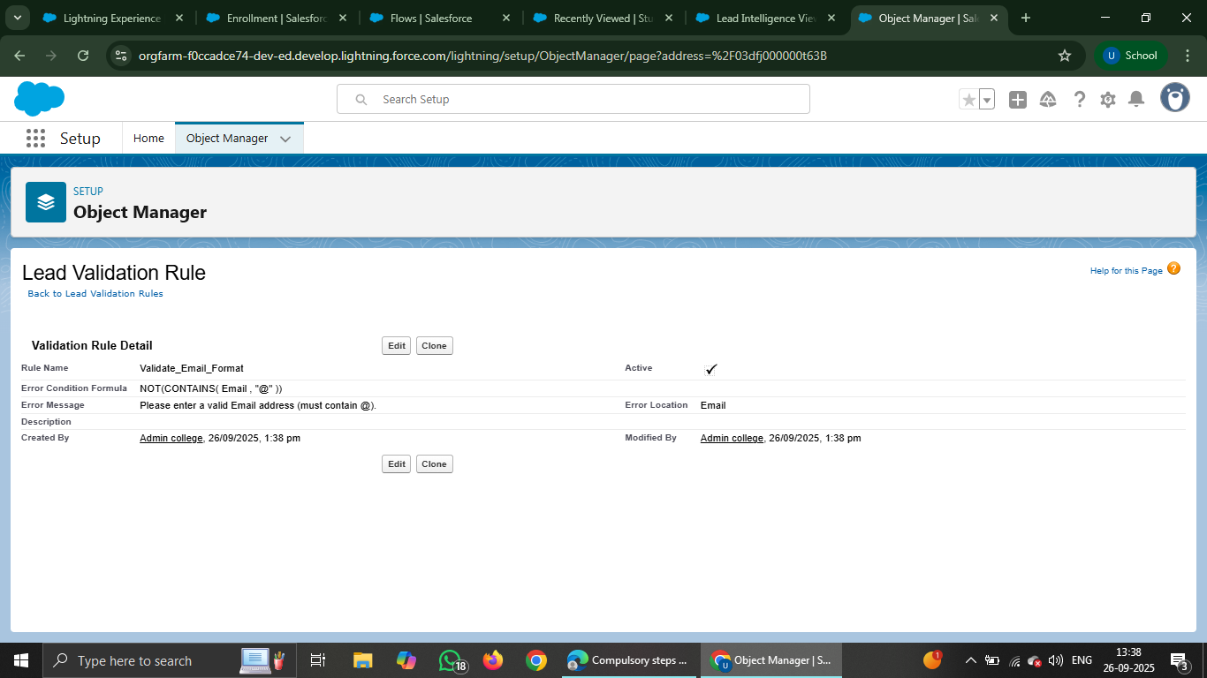

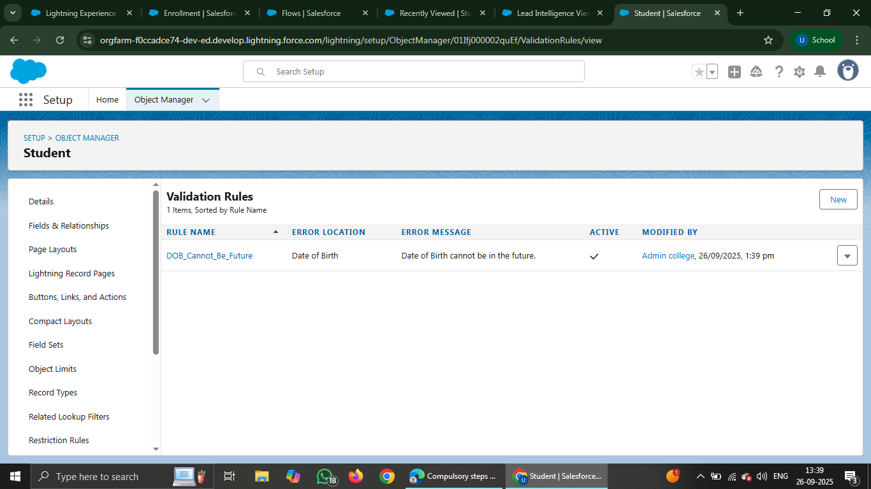

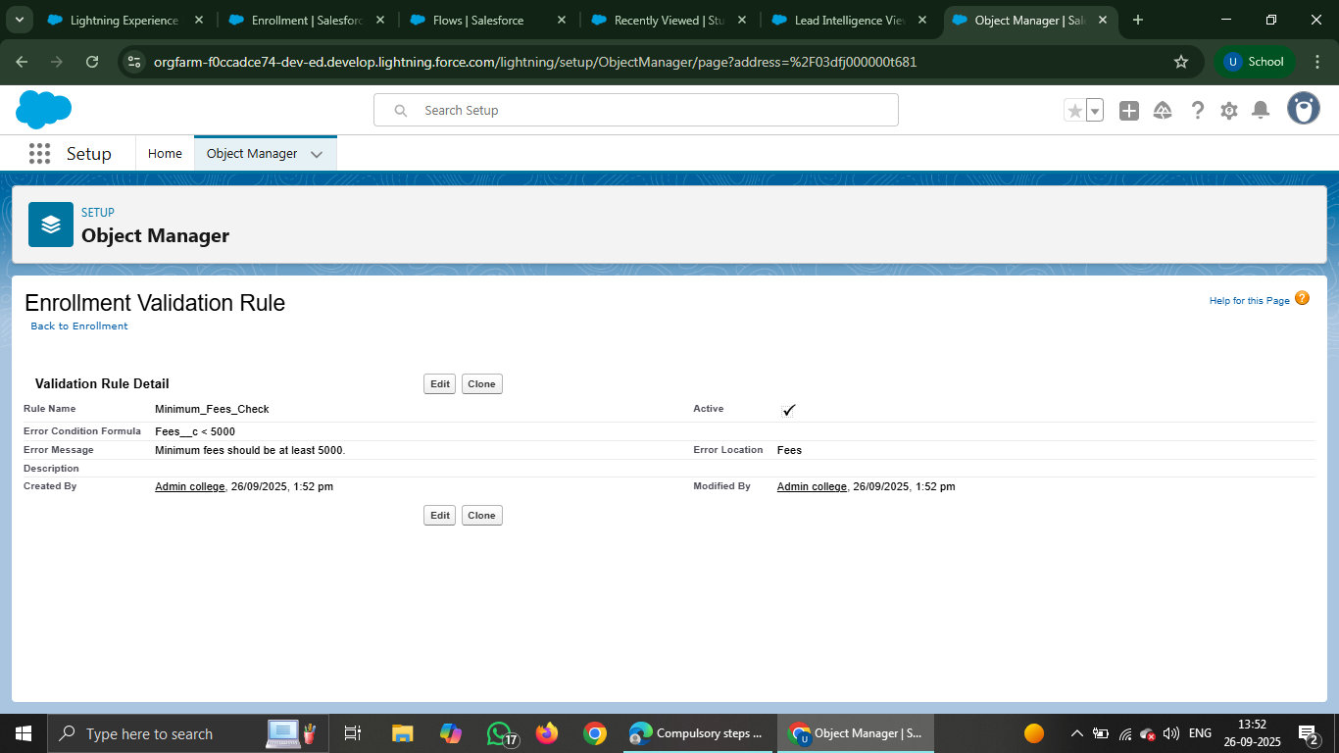

# Step 2: Create Flows

Flows automate processes such as sending fee reminders or updating student placement status.

1. Navigate to: Setup → Process Automation → Flows → New Flow.

2. Select Record-Triggered Flow.

3. Set the Object and Trigger conditions.

4. Add Decision/Action elements as required.

5. Save and Activate the Flow.

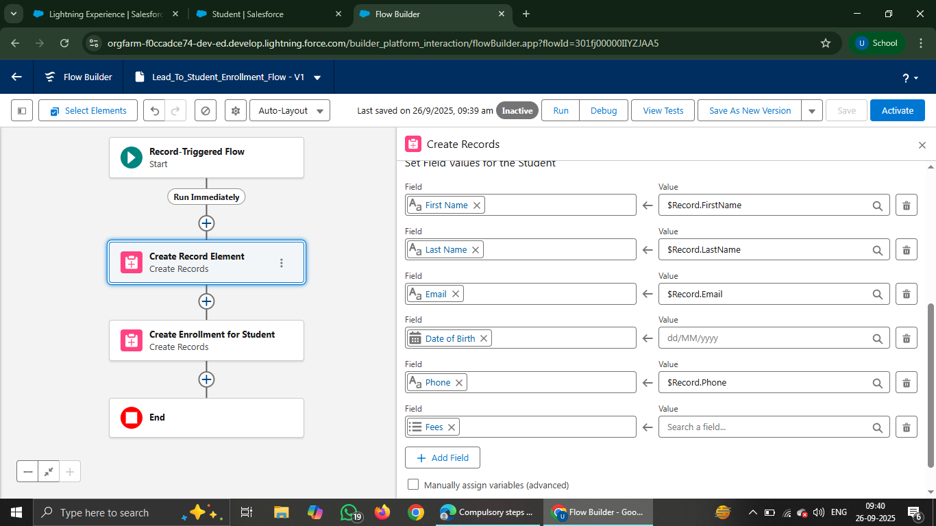

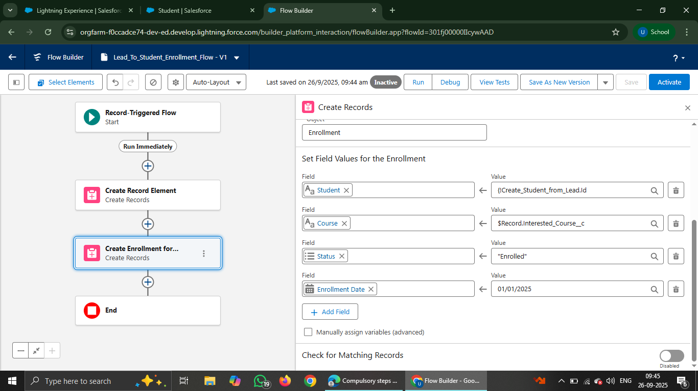

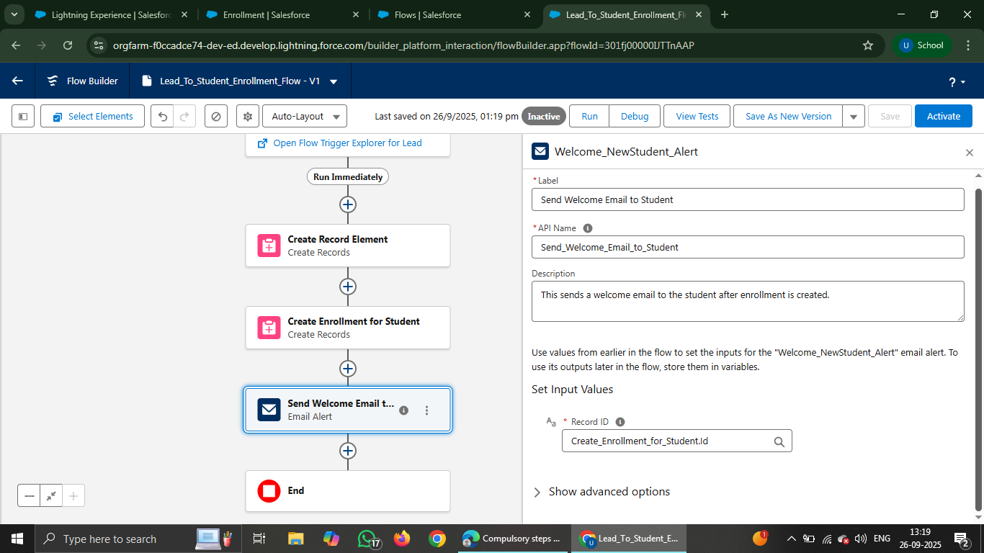

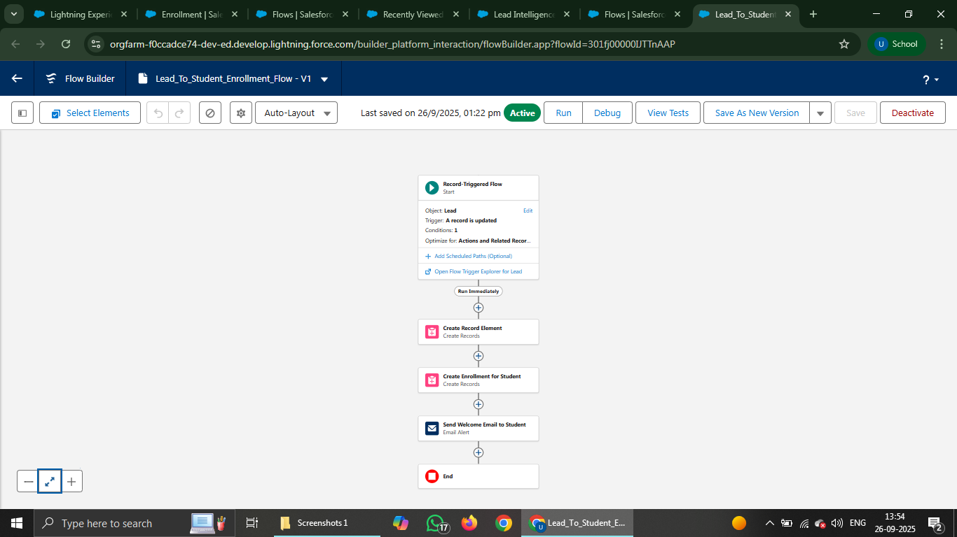

# Step 3: Create Reports and Dashboards

Reports and Dashboards provide visibility into Admissions, Fees, Attendance, and Placement data.

1. App Launcher → Reports → New Report.

2. Select the Object (Students, Fees, Attendance, Placement).

3. Apply Filters and Groupings.

4. Add Chart and Save the Report.

5. Navigate to Dashboards → New Dashboard → Add Report Components.

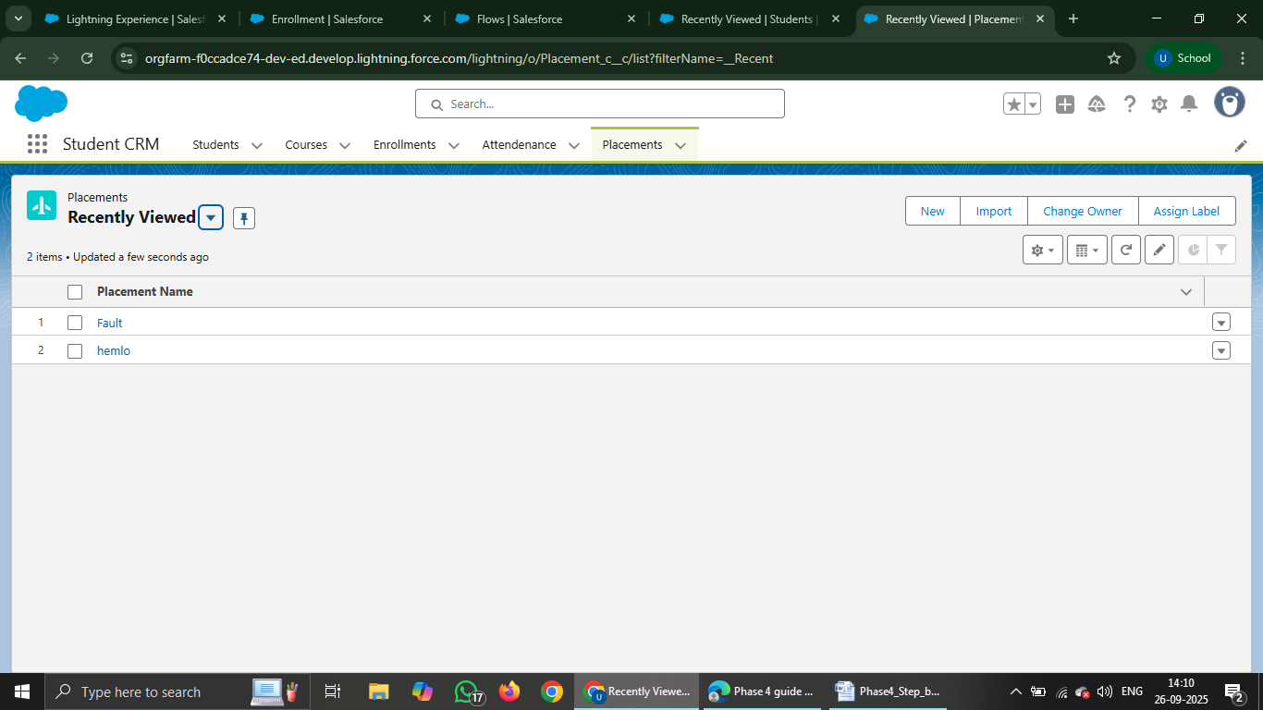

Email Template

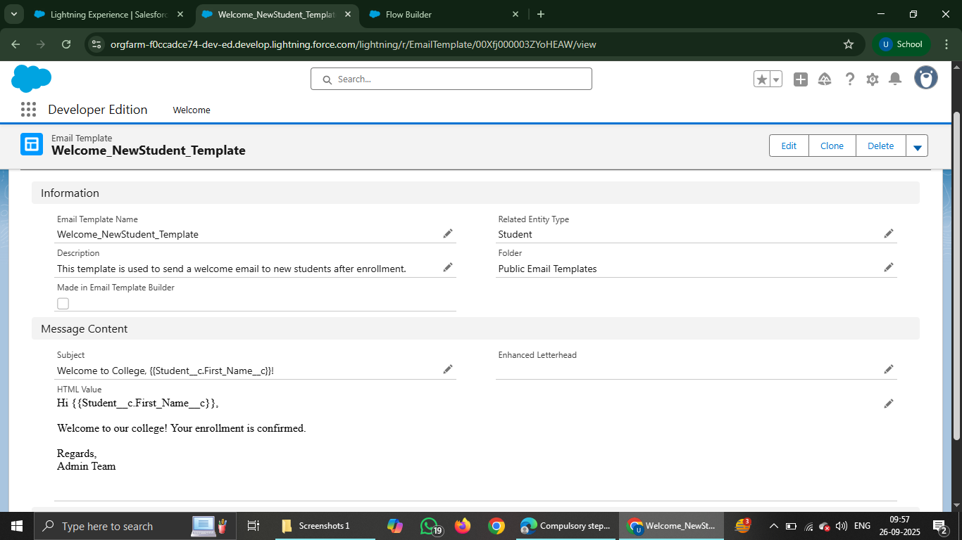

Email Classic Template

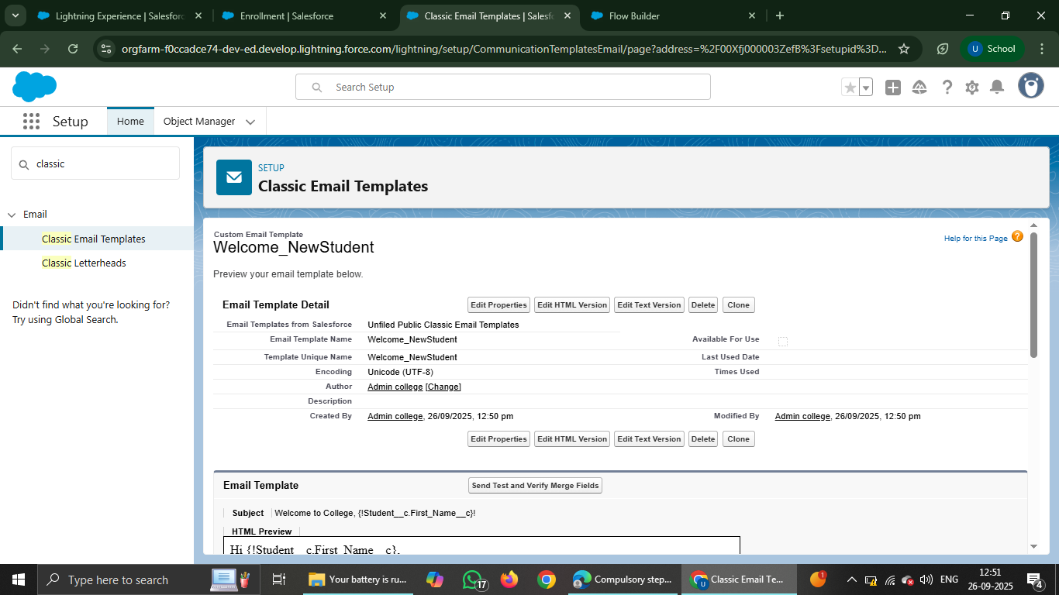

Email Alert

